Mrs Strickett

a-Level history paper 2: india c.1914-48: The road to independence – bridging work 2021

Transition material for A Level History
Paper 2: India c.1914-48: the road to independence
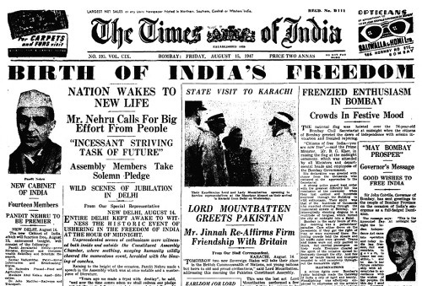

Introduction
I wonder how much you already know about Indian history? My guess? Not very much. Maybe you know that India used to be part of the British Empire, maybe you have heard of Gandhi, but my guess would be that is where your knowledge ends?
This unit will introduce you to the story of how India went from being a country that was under British control to an independent country ruling itself, and today being considered as having the fifth biggest economy in the world. The story of independence is not an easy one, nor a simple one. There will be religious tension between Hindus and Muslims on the way, massacres of innocent civilians and a lot of negotiating. But in the end, we will see how India achieved its freedom through partition – an event that created modern day India and Pakistan, led to the deaths of up to 2 million people, and saw up to 14 million people being moved from their homes.
Along the way you will learn valuable skills to help you both in your academic pursuit of history, but also many skills that will be applicable to daily life. Ultimately, this course will stretch your brain and help you to think more logically and more clearly. Good luck!
Contents

- Resource list.

- Transition Assignment

- Glossary

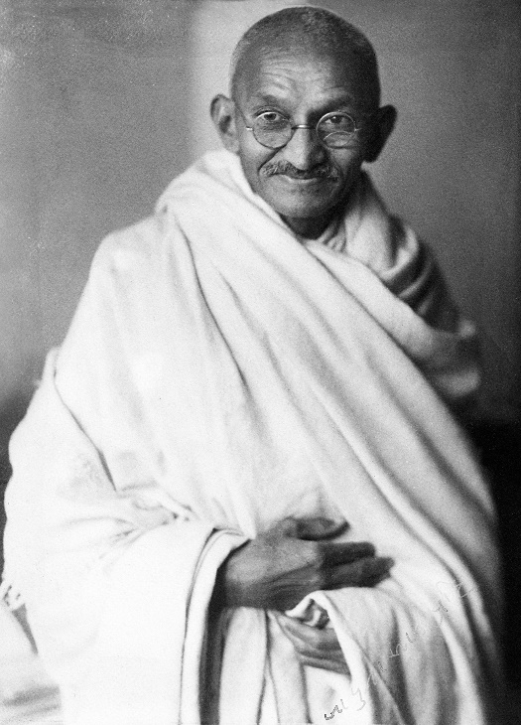
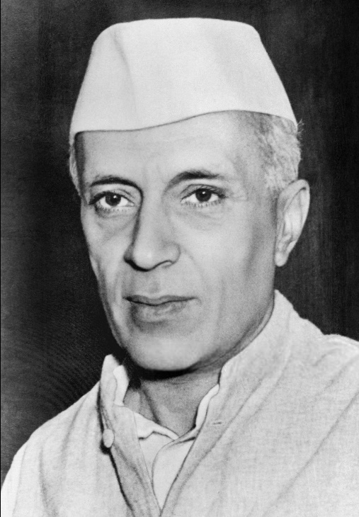
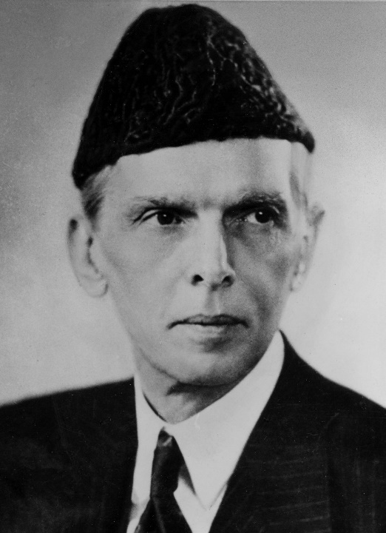
- Optional Extra Research

Resource List
You are not expected to use all these resources before we begin! However, it would be useful to use the resources marked with a * to give you a good context before we begin the course.
Books and Articles | - World War One. Six Extraordinary stories: https://www.bbc.co.uk/news/world-asia-india-46148207  - Living in the British Empire – India: http://www.nationalarchives.gov.uk/education/empire/g2/cs4/default.htm *  - From Empire to Independence. The British Raj in India 1858-1947: https://www.bbc.co.uk/history/british/modern/independence1947_01.shtml *
Film | - DVD: Gandhi *  - British Occupation of India in Colour – Full Documentary: https://www.youtube.com/watch?v=nhKYg641K3c *  - How did the British gain control of India? History – Empire. BBC Teach: https://www.youtube.com/watch?v=oNWTXaOotEA  - How the British managed to rule India: https://www.youtube.com/watch?v=F7GOh8qlLwQ  - British India during WW1. The Great War Special: https://www.youtube.com/watch?v=bFTSCjn6wKI

Transition Assignment
Research two of the following events and complete the table below:
- Indian Mutiny/Indian War of Independence 1857
- Amritsar Massacre 1919
- Salt Satyagraha 1930
- Partition of India 1947

Event 1
What happened?

What were the consequences?

Event 2
What happened?

What were the consequences?

Glossary
These are some of the key terms that we will use in the course. Please research their meaning and complete the table below.
Caste
Sepoy
Viceroy
Dominion Status
Satyagraha
Swaraj
Dyarchy
Round Table Conference
Ashram
Hartal
Maharajah
Partition

Optional Extra Research
Should you wish to complete extra research in preparation for the course then please do. Some examples of activities that you might want to complete are listed below:
- Create a timeline of Indian history from 1914-48. Make it as thorough as possible.
- Create a mind-map about the East India Company.
- Compile a list of British Prime Ministers from 1914-48. Research their views and actions on the British in India.
- Compile a list of British Viceroys of India from 1914-48. Complete extra research on each – key events during their terms in office, political cartoons depicting these; what do these reveal about them?
- Create a fact-file about the life of Gandhi. What did he do before he became involved in Indian politics? What were his beliefs and methods surrounding protest?
- Compare the religious beliefs of Hinduism and Islam. Where are they similar? Where are they different? How does Sikhism fit into this religious picture?

