Mrs Strickett

a-level history Paper 1: searching for Rights and Freedoms in USA 1917-96 – bridging work 2021

Introduction
It is great that you are considering studying History at A Level.

This pack contains a programme of activities and resources to prepare you for your study of the history of the USA during the twentieth century which is the topic for Paper 1.

Discovering the past is great fun. I hope that you will agree!
The USA can feel familiar to us, we share a language and many elements of culture are similar; Hollywood films and many popular TV shows show us stories of American life now and in the past, and events such as the US involvement in the World Wars, the assassination of JFK and the war in Vietnam are part of our shared history. In our Cold War topic particularly, we have looked at the impact of Presidents such as Truman and Reagan on international relations.
This unit covers the following themes:
Theme 1: The changing political environment, 1917–80
Theme 2: The quest for civil rights, 1917–80
Theme 3: Society and culture in change, 1917–80
Theme 4: The changing quality of life, 1917–80
The historical interpretations focus is: What impact did the Reagan presidency (1981–89) have on the USA in the years 1981–96?

Studying History at Advanced level will give you valuable skills to help you both in your academic work, but also many skills that will be applicable to daily life.
Contents
- Resource list

- Transition Assignment

- Glossary

- Optional Extra Research
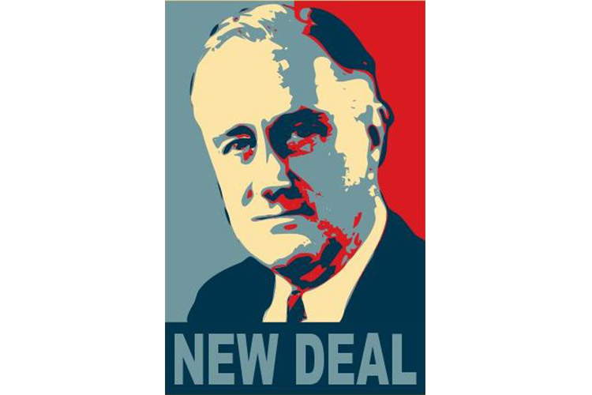
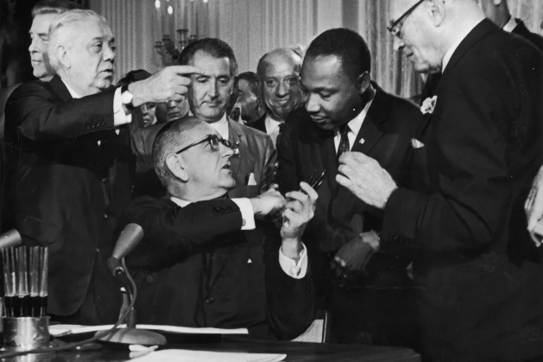

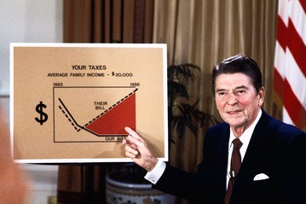

Resource List
You are not expected to use all these resources before we begin! However you may wish to look for copies of these books second-hand or online
The main textbook that we will use in class for both Units in Year 12 is the Pearson ‘Searching for Rights and Freedoms in the Twentieth Century’ listed first in the table below. There will be enough copies for you to use in school, but you will not be able to take these home so you may want to look into buying your own copy.
Resource | Type | For students and/or teachers?
Rosemary Rees and Jane Shuter, Edexcel AS/A Level History, Paper 1&2: Searching for rights and freedoms in the 20th century Student Book + ActiveBook (Edexcel GCE History 2015) (Pearson 2015) | Main textbook for the course | For teachers and students.
Vivienne Sanders, Access to History: In search of the American Dream: the USA, c1917–96 (Hodder 2018) | Textbook | For students and teachers. Takes a chronological approach rather than thematic.
Robin Bunce and Laura Gallagher, Edexcel AS History, Unit 1: Pursuing Life and Liberty: Equality in the USA, 1945–1968 (Pearson, 2009) | Textbook | For students. Written for 2008 specification.
Peter Clements, Prosperity Depression and the New Deal Third Edition, Access to History (Hodder Education, 2005) | Textbook | Written for students.
David Mauk and John Oakland, American Civilization (Routledge, sixth edition, 2014) | Textbook | For teachers and students.
Derrick Murphy, Kathryn Cooper and Mark Waldron, The United States 1776–1992 (Collins, 2001) | Textbook | Accessible for students.
Vivienne Sanders, Civil Rights in the USA, 1945–1968, Access to History (Hodder Education, 2008) | Textbook | For students
Doug and Susan Willoughby, The USA 1917–45, Heinemann Advanced History (Heinemann, 2000) | Textbook | For students
Hugh Brogan, The Penguin History of the United States of America (Penguin, 2001) | General text | Accessible for students.
Eric Rauchway, The Great Depression and the New Deal: A Very Short Introduction (Oxford University Press, 2008) | General introductory text | Primarily for teachers, however selections are also helpful for students.
Robert J McMahon, The Cold War: A Very Short Introduction (Oxford University Press, 2003) | General introductory text | Primarily for teachers, however selections are also helpful for students.
PBS (1990)  Eyes on the Prize  Season 1 and Season 2 | Documentary series | For teachers and students. Excellent series of documentaries covering all aspects of the struggle for black rights in America.

Transition Assignment
Research two of the following events and make notes in the table below:
- The Red Scares of 1919 and 1947-c57
- The Montgomery bus boycott (1955-56)
- Mai Lai massacre (Vietnam, 1968)
- The Watergate scandal (1972)
- Reagan’s election victory (1979)
Event 1
What happened?

What were the consequences? (Think broadly – for the political situation, for individual American citizens etc)

Event 2
What happened?

What were the consequences? (Think broadly – for the political situation, for individual American citizens etc)

Glossary
These are some of the key terms that we will use in the course. Please research their meaning and complete the table below.
Republican
Democrat
Separation of powers
Congress
Senate
House of Representatives
Tariffs
Laissez-faire
Inaugural speech
Deep South
Gross National Product
Segregation
14th amendment
Money supply
Inflation
Stagflation
Baby boom

Optional Extra Research
Should you wish to complete extra research in preparation for the course then please do! Some examples of activities that you might want to complete are listed below:
- Create a timeline of US history from 1917-96. Include each of the presidents and their party. Include US involvement in war and any other significant events (e.g. those suggested in the transition assignment above)

- Find out about the Great Depression – causes, impact and recovery

- Research two of the US presidents from the twentieth century. Create a fact file including their background, achievements in office, relationship with the media and congress and any other interesting details. Compare the two Presidents using details you’ve researched. Which man was more successful and why?

- Research civil rights movements in the USA in the 1900s, for example the campaigns for the rights of women, gays, native Americans, Mexican Americans and Black Americans. Consider their aims, methods and successes.

- Research one of the following significant individuals – why do they appear in our history course?

  - Booker T. Washington
  - W.E.B. Du Bois
  - A. Philip Randolf
  - Martin Luther King Jr
  - Fannie Lou Hamer
  - Malcolm X
  - Stokely Carmichael
  - Thurgood Marshall
  - Russell Means
  - Cesar Chavez
  - Harvey Milk

