Dennis Antiri
[Company name] [Company address]
a-level business bridging work 2021

Business A-Level Summer Research 1
Research Focus: External factors affecting business
COVID- 19 over the last 14 months has affected many small to large businesses across the world. The damage has been significant and something that businesses did not foresee or factor into their contingency planning (a plan designed to take account of a possible future event or circumstance). When considering COVID-19 it is important to understand that this is an external (outside of the business) that has led to significant financial lose and in some cases, business shutting down entirely.
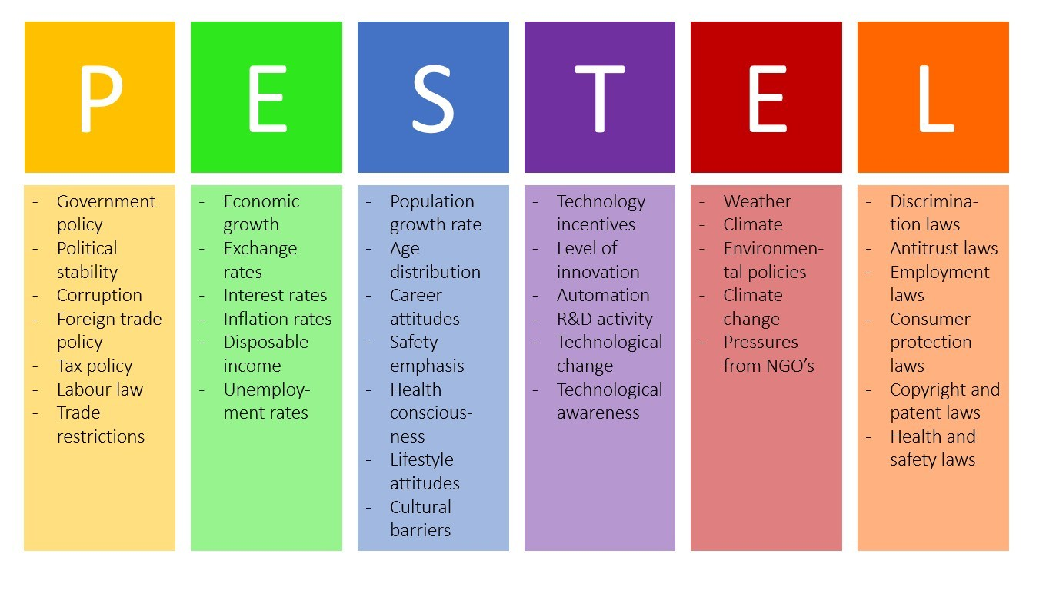
A PESTLE (see below) takes into consideration many factors outside of the business environment. These factors will affect business costs and the demand of goods and services.
https://www.youtube.com/watch?v=sP2sDw5waEU – provides general overview
https://www.youtube.com/watch?v=F0KQ-h6v3-s – provides general overview linked to Amazon
Task
Research 2 businesses that have been positively and negatively affected by COVID-19 in the last few months. You will need to provide information on the following areas:
- Name of business and type of business the operate
- Structure and locations of business – online (how many countries do they operate in across the world), high-street (how many stores do they have)
- Research the financial performance before/during/currently AND identify trends – refer to 2019 and 2020 figures…….2021 figures for some businesses/industries maybe available.
- Staff – have the businesses retained, cut or furloughed employee – consider the positive or negative impact of this decision
- Prices – research to explain how the business have responded to lock downs in an effort to attract and retain customers
- Technology – research to explain how each of the businesses have used technology to support business operation – consider e-commerce, m-commerce, social media platform.
Business A-Level Summer Research 2
Essay Question

G-Free Ltd’s finance manager suggests funding the £28m investment and further growth by becoming a public limited company and selling shares.

Is selling shares on the Stock Exchange the best way to raise large amounts of capital for all organisations?

Justify your view. [12 marks]
__________________________________________________________________________________
Teacher Note – In this circumstance the most appropriate alternative forms to raise large capital would be a bank loan, venture capitalist or crowd funding – research 2-3 pros and cons and discuss ONE of the options listed in your essay.
Support videos/information on other sources of information available to business;
- https://www.youtube.com/watch?v=JSIfwHDpkro
- https://www.tutor2u.net/business/reference/sources-of-finance-bank-loans
- https://www.tutor2u.net/business/reference/crowdfunding
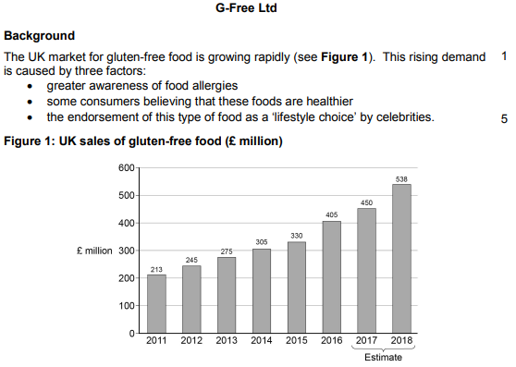
Case Study Extract
Points to consider - always refer to data in your arguments if detailed in a case study
- Figures show that UK sales is increasing each at a positive rate
- Investment of £28million is needed as market shows significant growth
Extract continued….
Success with gluten-free bread led G-Free Ltd to develop a wider range of products from cakes and biscuits to croissants and crumpets – all gluten-free and many were developed from employee suggestions. In 2014 the company invested heavily in two new large bakeries. The existing suppliers could not offer the range or volumes now needed by GFree Ltd. Its new products and increased scale meant that G-Free Ltd required more ingredients from a rising number of suppliers.
Costs associated with this expansion were seen as the reason for the business not turning sales growth into profit.
In 2015 G-Free Ltd experienced a serious problem in its operations. Some products were found to contain traces of gluten. Flour from one of its new suppliers was contaminated. G-Free Ltd acted swiftly to withdraw the products – mindful of the importance of maintaining the trust of its customers and reviewed its quality control systems.
The continued growth of this market has recently attracted larger firms. Heinz, Nestlé and Warburtons have each launched their own gluten-free ranges. These firms have lower unit costs due to larger scale and the use of more technologically advanced systems. They also benefit from strong brand images from their other products that sell in mass markets; this has helped them enter the gluten-free niche.
The Operations Manager of G-Free Ltd believes that the company must react to this threat by reviewing its optimum resource mix, particularly as labour costs at G-Free Ltd are rising. The company plan a move towards a lean production system that will be more capital intensive. It will also aim to improve operational performance by reducing the number of suppliers it works with from 28 to 14.
The plan will see a reduction in staffing at the factories. This is opposed by the Human Resources Manager who highlights that many of the staff have stayed loyal to the company for many years.
The plan will be completed by late 2018 at a cost of £28m. The Finance Manager suggests the company fund this, and further growth, by becoming a public limited company. However, the founder, Stephanie Morris, sees herself and the original directors as key people to help ensure that the business stays true to its original aims and feels this may be threatened if the ownership is changed in this way.
_________________________________________________________________________________
Structure of assignment – ALL paragraphs explained in DETAIL
Introduction: Definition of public limited company
Paragraph One: 2 strong arguments for public limited and one strong argument against
Paragraph Two: 2 strong arguments for chosen alternative source of finance and one strong argument against
Evaluation: Provide a strong summary stating the most appropriate method of financing for G-Free Ltd ………………you should use this sentence to help start your evaluation “The arguments are finally balanced but feel the most appropriate method of financing is……………”

